**Fundamentals of Computer Programming**

**ASSIGNMENT**

**III**

**Prepared by: Gupta Bdr Chhetri**

**Shift: Morning**

**Roll Number: 6**

**BSc CSIT**

1. **Write a program to display Sum of two numbers.**

**Code:**

|  |
| --- |
| **/\***  **PROGRAM: To Display Sum Of Two Numbers**  **\*/**    **/\***  **Step 1: Start**  **Step 2: Declare variables a, b and sum=0**  **Step 3: Operate sum=a + b**  **Step 4: Finally display the value of sum**  **Step 5: Stop**  **\*/**  **#include <stdio.h>**  **#include<conio.h>**  **void main()**  **{**  **float a,b,sum;**  **printf("Enter Two numbers: ");**  **scanf("%f%f", &a,&b);**  **sum=a+b;**  **printf("The Sum of two numbers is %f\nThankYou",sum);**  **getch();**  **}** |

**Output:**

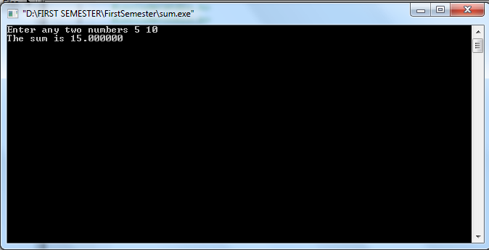

1. **Write a program to display if the number is positive or negative.**

**Code:**

|  |
| --- |
| **/\***  **PROGRAM: To display if the number is positive of negative**  **\*/**  **/\***  **Step 1: Start**  **Step 2: Declare variable a**  **Step 3: If a>0 then the number is positive**  **If a<0 then the number is negative**  **Step 4: End**  **\*/**  **#include<stdio.h>**  **#include<conio.h>**  **void main() {**  **float YourNumber;**  **printf("Enter your number ");**  **scanf("%f",&YourNumber);**  **if(YourNumber>0)**  **printf("The number is positive");**  **else**  **printf("The number is negative");**  **getch();**  **}** |

**Output:**

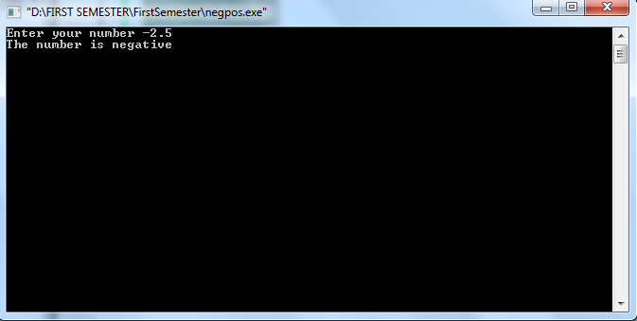

1. **Write a program to display whether the number is even or odd.**

|  |
| --- |
| **/\***  **PROGRAM: To display if the number is even of odd.**  **\*/**  **/\***  **Step 1: Start**  **Step 2: Declare variable a**  **Step 3: If a%2==0 then the number is even**  **Else the number is odd**  **Step 4: End**  **\*/**  **#include<stdio.h>**  **#include<conio.h>**  **void main() {**  **intYourNumber;**  **printf("Enter your number ");**  **scanf("%d",&YourNumber);**  **if(YourNumber%2==0)**  **printf("The number is even");**  **else**  **printf("The number is odd");**  **getch();**  **}** |

**Output:**

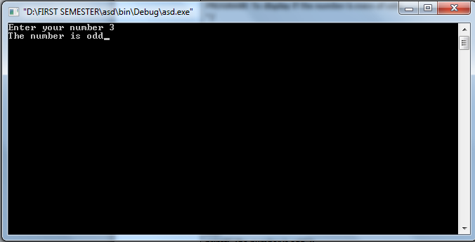

1. **Write a program to read three numbers and print the greatest.**

|  |
| --- |
| **/\***  **PROGRAM: To display the greatest number among three numbers.**  **\*/**  **/\***  **Step 1: Start**  **Step 2: Declare variable a,b,c**  **Step 3: If a>b&&a>c then a is greatest**  **If b>a&&b>c then b is greatest**  **If c>a&&c>b then c is the greatest**  **Step 4: End**  **\*/**  **#include<stdio.h>**  **#include<conio.h>**  **void main ()**  **{**  **int Number1,Number2,Number3;**  **printf("Enter any three numbers ");**  **scanf("%d %d %d",&Number1,&Number2,&Number3);**  **if(Number1>=Number2 && Number1>=Number3)**  **printf("The greatest number is %d",Number1);**  **if(Number2>=Number1 && Number2>=Number3)**  **printf("The greatest number is %d",Number2);**  **if(Number3>=Number1 && Number3>=Number2)**  **printf("The greatest number is %d",Number3);**  **getch();**  **}** |

**Output:**

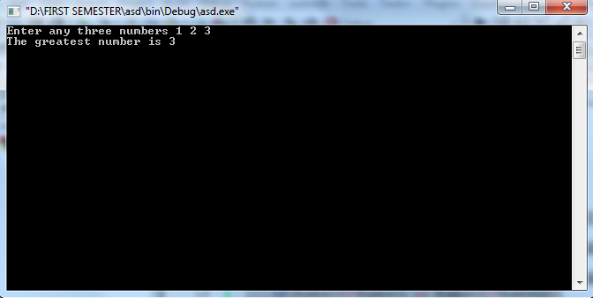

1. **Write a program to find the sum of the series 1+2+3+4….. upto entered n numbers.**

|  |
| --- |
| **/\***  **PROGRAM: To display the sum of 1+2+3+…..+n**  **\*/**  **/\***  **Step 1: Start**  **Step 2: Declare variable n**  **Step 3: Declare a=0**  **Step 4: For I = 1 to n**  **a = a + I;**  **Next I;**  **Step 5: The sum is a**  **Step 6: End**  **\*/**  **#include<stdio.h>**  **#include<conio.h>**  **void main()**  **{**  **intYourNumber,var=0;**  **printf(“Enter any number ”);**  **scanf(“%d”,&YourNumber);**  **for(int i=1; i<=YourNumber;i++)**  **var=var+i;**  **printf(“The sum is %d”,var);**  **getch();**  **}** |

**Output:**

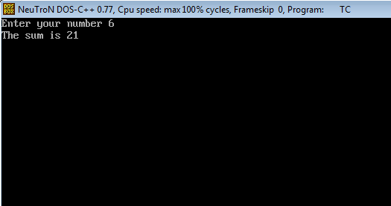

1. **Write a program to find the factorial of a number.**

|  |
| --- |
| **/\***  **PROGRAM: To display the factorial of a number**  **\*/**  **/\***  **Step 1: Start**  **Step 2: Declare variable n**  **Step 3: Declare a=1**  **Step 4: For I = 1 to n**  **a = a * I;**  **Next I;**  **Step 5: The factorial is a;**  **Step 6: End**  **\*/**  **#include<stdio.h>**  **#include<conio.h>**  **void main ()**  **{**  **intYourNumber,variable=1,i;**  **printf("Enter any number ");**  **scanf("%d",&YourNumber);**  **for (i = 1; i<= YourNumber; i++ )**  **variable=variable*i;**  **printf("The factorial is %d",variable);**  **getch();**  **}** |

**Output:**

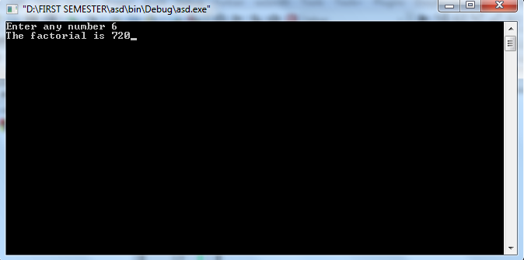

1. **Write a program to read first 20 numbers and display sum of even numbers.**

|  |
| --- |
| **/\***  **PROGRAM: To display the sum of even numbers of first 20 numbers**  **\*/**  **/\***  **Step 1: Start**  **Step 2: Declare variable a=0**  **Step 3: For I = 1 to 20**  **If I%2==0 then a=a+I;**  **Else Next I;**  **Step 5: The sum is a;**  **Step 6: End**  **\*/**  **#include<stdio.h>**  **#include<conio.h>**  **void main ()**  **{**  **int variable=0,i;**  **for (i = 1; i<= 20; i++ )**  **if(i%2==0)**  **variable = variable + i;**  **printf("The sum is %d",variable);**  **getch();**  **}** |

**Output:**

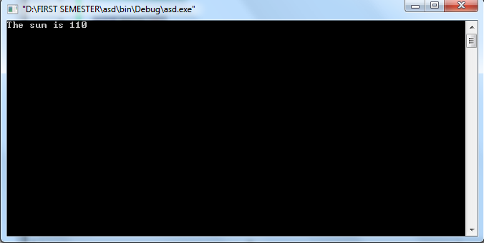

1. **Write a program to read a number and display its divisors.**

|  |
| --- |
| **/\***  **PROGRAM: To display the divisors of a number**  **\*/**  **/\***  **Step 1: Start**  **Step 2: Declare variable n**  **Step 3: For I = 1 to n**  **If n%I==0 then print I;**  **Else Next I;**  **Step 4: End**  **\*/**  **#include<stdio.h>**  **#include<conio.h>**  **void main ()**  **{**  **inti,YourNumber;**  **printf("Enter any number ");**  **scanf("%d",&YourNumber);**  **for (i = 1; i<= YourNumber; i++ )**  **if(YourNumber%i==0)**  **printf(" %d",i);**  **getch();**  **}** |

**Output:**

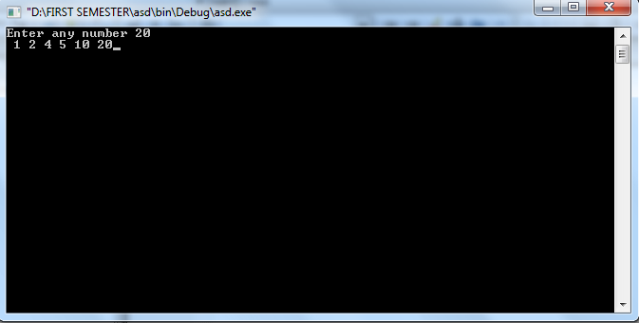

1. **Write a program to display if the number is prime or not.**

|  |
| --- |
| **/\***  **PROGRAM: To check if the number is prime or not.**  **\*/**  **/\***  **Step 1: Start**  **Step 2: Declare variable n,a=0**  **Step 3: For I = 1 to n**  **If n%I==0 then a=a+1;**  **Else Next I;**  **Step 4: If a==2 the the number is prime**  **Else the number is composite**  **Step 5: End**  **\*/**  **#include<stdio.h>**  **#include<conio.h>**  **void main ()**  **{**  **inti,YourNumber,Variable=0;**  **printf("Enter any number ");**  **scanf("%d",&YourNumber);**  **for (i = 1; i<= YourNumber; i++ )**  **if(YourNumber%i==0)**  **Variable=Variable + 1;**  **if(Variable==2)**  **printf("The number you entered is prime");**  **else**  **printf("The number you entered is composite");**  **getch();**  **}** |

**Output:**

